Yellow marked code needs to adjust on your needs
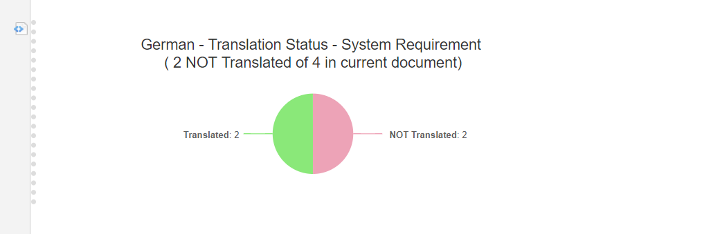
{show:wiki}
## GERMAN ############
#set( $WItype = "systemrequirement" )
#set( $WICustFieldHasTrans = "german_description" )
#set( $Language1 = "German" )

## CODE

##Get Project ID
#set($project = $projectService.getProject($page.getProject()))
#set($projectId=$project.getId())

##Get Work Item type Name
#set($currentProject = $trackerService.getTrackerProject($projectId))
#set($wiTypeEnum = $currentProject.getWorkItemTypeEnum())
#set($allWiTypes = $wiTypeEnum.getAvailableOptions($wiTypeEnum.getControlKey()))
#foreach($type in $allWiTypes)
#if($type.id == $WItype)
#set($TypeName = $type.name)
#end
#end

##Get current document
#set($apo = '"')
#set($thisDocument = "$apo$page.getSpace.getName()/$page.getName()$apo")

#set($query = "document.id:$thisDocument")
#set($workItems = $transaction.workItems().search().query($query))

#set($queryAllTYPE = "project.id:$projectId AND document.id:$thisDocument AND type:$WItype")
#set($WISizeAllTYPE= $transaction.workItems().search().query($queryAllTYPE).size())

## GERMAN (Language1)
#set ($WICustFieldHasTrans =$WICustFieldHasTrans.KEY )
#set( $queryLang1TYPE = "project.id:$projectId AND document.id:$thisDocument AND type:$WItype AND NOT HAS_VALUE:$WICustFieldHasTrans" )
#set( $WISizeLang1TYPE = $transaction.workItems().search().query($queryLang1TYPE).size() )

#set ( $WISizeNTTYPE = $mathTool.sub($WISizeAllTYPE, $WISizeLang1TYPE) )

## HIGHCHART ####

#highchartStart("$Language1 - Translation Status - $TypeName <br>( $WISizeLang1TYPE NOT Translated of $WISizeAllTYPE in current document)" "" 600 200)

#set( $highchartColors = ["EDA3B7","8AE879"] )
#addHighchartPieDataSet("Count" "'NOT Translated',$WISizeLang1TYPE : 'Translated',$WISizeNTTYPE")

#addHighchartAdditionalOptions("options.plotOptions = {pie:{dataLabels: {enabled:true,format: '<b>{point.name}</b>: {point.y:.0f}'},borderWidth:1,animation:true}};")

#addHighchartAdditionalOptions("options.tooltip = {formatter: function(){ return ''+ this.point.name + ': <b>'+ this.y + '</b>' }};")
#highchartEnd()
{show}
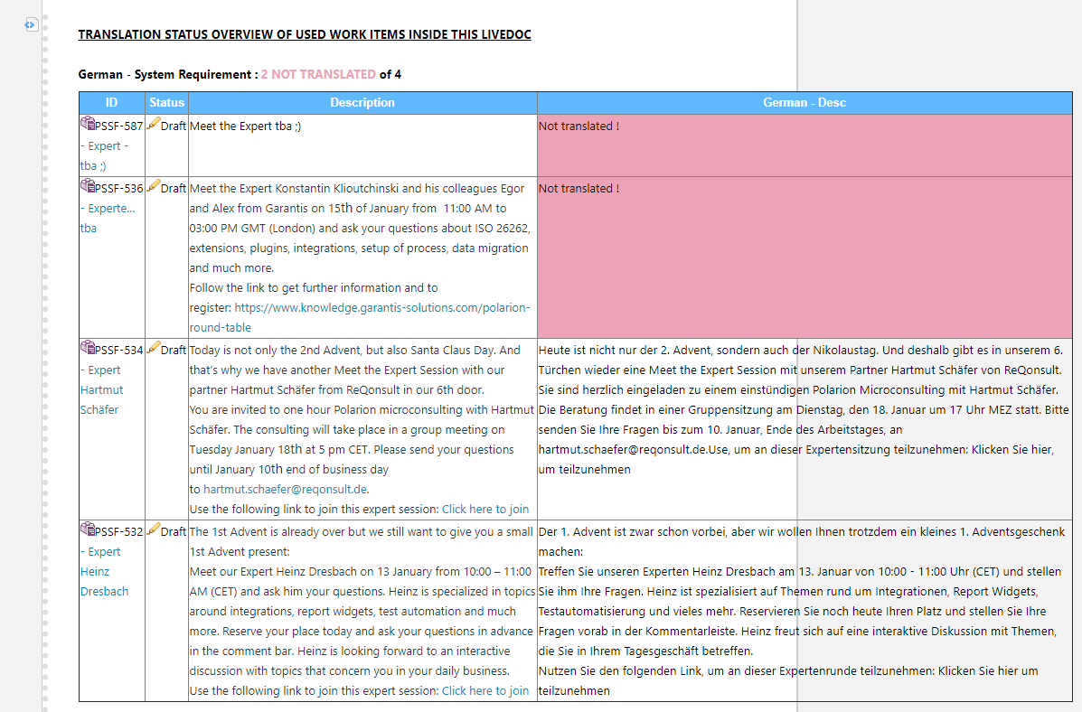
{show:wiki}

## GERMAN ############

#set( $WItype = "systemrequirement" )
#set( $WICustFieldHasTrans = "german_description" )
#set( $Language1 = "German" )

########### CODE

## variables
#set( $COLORTableHeaderBackground="#61B9FF" )
#set( $COLORTableHeaderText="#FFFFFF" )
#set( $COLORnottranslated="#EDA3B7" )

##Get Project ID
#set($project = $projectService.getProject($page.getProject()))
#set($projectId=$project.getId())

##Get Work Item type Name
#set($currentProject = $trackerService.getTrackerProject($projectId))
#set($wiTypeEnum = $currentProject.getWorkItemTypeEnum())
#set($allWiTypes = $wiTypeEnum.getAvailableOptions($wiTypeEnum.getControlKey()))
#foreach($type in $allWiTypes)
#if($type.id == $WItype)
#set($TypeName = $type.name)
#end
#end

##Get current document
#set($apo = '"')
#set($thisDocument = "$apo$page.getSpace.getName()/$page.getName()$apo")

#set($query = "project.id:$projectId AND document.id:$thisDocument")
#set($workItems = $transaction.workItems().search().query($query))

## DE ############
#set($queryAllWI = "project.id:$projectId AND document.id:$thisDocument AND type:$WItype")
#set($WISizeAllWI= $transaction.workItems().search().query($queryAllWI).size())

## DE
#set ($WICustFieldHasTrans =$WICustFieldHasTrans.KEY )
#set($queryLang1WI = "project.id:$projectId AND document.id:$thisDocument AND type:$WItype AND NOT HAS_VALUE:$WICustFieldHasTrans ")
#set($WISizeLang1WI = $transaction.workItems().search().query($queryLang1WI).size())
<b><u>TRANSLATION STATUS OVERVIEW OF USED WORK ITEMS INSIDE THIS LIVEDOC</u></b><br><br>
<b>$Language1 - $TypeName : <span style="color:$COLORnottranslated;">$WISizeLang1WI NOT TRANSLATED</span><span style="color:black;"> of $WISizeAllWI</span></b>
<table border="1" width="1100">
<br>

<tr>
<th style="color:$COLORTableHeaderText;background-color:$COLORTableHeaderBackground;">ID</th>
<th style="color:$COLORTableHeaderText;background-color:$COLORTableHeaderBackground;">Status</th>
<th style="color:$COLORTableHeaderText;background-color:$COLORTableHeaderBackground;">Description</th>
<th style="color:$COLORTableHeaderText;background-color:$COLORTableHeaderBackground;">$Language1 - Desc</th>
</tr>

#foreach($workItem in $workItems)
#if ( $workItem.getOldApi().getType().getId().equals("$WItype") )
<tr>
<td>$workItem.fields().id().render().withLinks().withTruncatedTitle(45).openLinksInNewWindow()</td>
<td>$workItem.fields().status().render()</td>
<td>$workItem.fields().description().render()</td>
#if( $workItem.getOldApi().getCustomField("$WICustFieldHasTrans") )
<td>$workItem.fields().get("$WICustFieldHasTrans").render</td>
#else
<td bgcolor="$COLORnottranslated">Not translated !</td>
#end
</tr>
#end
#end
</table>

</table>
{show}
Copy the code and add the code via insert Wiki:
