Guidelines for Remote Working with NX

Overview
This document provides a high-level overview of the requirements to work with NX when away from the normal office environment. It does not cover all possible configuration scenarios, but it does explore several different options.
These guidelines also apply in principle to other Siemens Digital Industries Software applications, that use the Siemens PLM License Server, such as, Simcenter 3D, Tecnomatix and Teamcenter.
There are three main elements of the NX installation to consider:
- Access to a license for NX
- The NX software installation
- Accessing NX data
Another factor is the network connectivity available to the home worker into the office environment. The following scenarios will be considered:
- The remote user has access to the office environment via VPN (Virtual Private Network)
- There is no (or limited) network connectivity from the remote location to the office
This information is to help guide the NX system administrator to the most appropriate option when planning remote working with NX.

Caveat
This document does not provide specific technical solutions or recommendations. The expectation is that the system administrator will coordinate with their corporate IT department to provide the necessary technical solutions and the software required to enable the NX user to work remotely.

Audience
These guidelines will aid the NX system administrator to assess the options available to enable the use of NX for remote working. It is not intended as a self-help guide for the NX user to configure their system to enable remote working. Any installation and configuration requirements must be coordinated with their corporate IT support.

1.3 Configuration Scenarios

Several configuration scenarios have been considered, including:

- Accessing the NX office environment via Remote Desktop - refer to Section 2
- Using NX with remote access (via VPN) – refer to Section 3
- Using NX with no (or limited) remote access – refer to Section 4

Scenario 1: Running NX via Remote Desktop
In this scenario the following is assumed:
- The user has a computer that is not their normal ‘engineering’ workstation
- There is no local installation of NX
- A VPN (Virtual Private Network) connection is available to the corporate network
The benefit of running NX remotely in this way is the minimal configuration requirements. There is no additional NX installation or alternative licensing method required. (An exception to this is if the office workstation uses a standalone node-locked license. Please refer to Section 2.4 for further information.)
Note: Running NX via Windows Remote Desktop session is not officially supported, but it is being explored here as a stop-gap measure. Other Remote Desktop applications and protocols are available, such as VNC, but they are not discussed here. (Supported VDI solutions, such as Citrix XenDesktop and VMware Horizon are not considered here as they require the deployment and configuration of additional resources, which takes careful planning to implement and optimize, and may not be appropriate as short-term solution.)

Workstation Requirements
If the user is working remotely and does not have direct access to their office computer, then it is possible to use an alternative (‘home’ or ‘business’) computer to connect to their office workstation and open a remote desktop connection (RDC) to run NX.

Network Requirements
An internet connection and access to the office network via VPN is required. The VPN software will be provided by the company’s IT department and the user will need to address any VPN related issues with their IT support.

Remote Desktop Connection
The office-based computer must have the Remote Desktop Protocol (RDP) server software installed and the local computer requires RDP client install, this is typically part of standard Windows installation. To help ensure an optimal level of graphics performance, after the remote NX session has started, review the NX log file to check that the high performance (OGL capable) NVIDIA/AMD graphics card has been used. Select ‘File – Help – Log File’ and search for the ‘graphics device’ entry, which should list the discrete graphics card, rather than the onboard graphics, for example:
Graphics device: Quadro P3000/PCIe/SSE2
If the onboard graphics device is listed, please call Siemens Technical support for further advice.

NX Licensing
When running via a Remote Desktop session, NX can access a floating or node-locked license from the license server in the normal way. However, if the NX installation on the office machine is licensed using a ‘standalone node-locked’ license (i.e. one that does not have a SERVER line), then an ‘NX Initialization Error’ will be displayed, stating ‘Cannot checkout a license within a Windows Terminal Services session’:
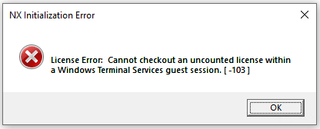
If you encounter this issue, it can be overcome by obtaining a ‘server’ license and installing the Siemens PLM License Server software on the office-based workstation. Please contact Siemens Technical Support for further advice.

Performance
A typical home internet connection may not provide the performance necessary to allow a graphical application, such as NX, to run smoothly, mainly due to either network latency or speed. NX will work, but the user may find the delay in the graphics display and the UI interaction too inefficient for extended periods of work. (In which case consider one of the alternative remote working options.)

Scenario 2: Running NX Locally with Remote Access (via VPN) to the Office
In this scenario the following is assumed:
- The user has a workstation that meets the hardware requirements to run NX
- The workstation has a local installation of NX
- A VPN (Virtual Private Network) connection in to the corporate network
- NX is used native or in a Teamcenter managed environment (4-tier)
- Licenses will be accessed from the corporate license server

Workstation requirements
The expectation is that the user will have the workstation they typically use in the office, but they have moved it to a remote location. So, the workstation should meet the operating system and graphics card requirements to run NX.
(Note: A typical ‘home or business’ computer may not be suitable for running NX. For further details of the NX operating system and hardware requirements, please refer to the Hardware and Software Certifications page on the support website.)

VPN Access
The VPN solution will be provided by the company’s IT department and the user will need to address any VPN related issues with their IT support.
(Note: If remote access is via Microsoft Direct Access, some additional configuration may be required to enable the remote access to the license server. Please contact Siemens Technical Support for further details.)

Licensing
The licenses required to launch NX will be accessed from the corporate license server. As communication with the license server is via VPN, it may be necessary to increase the time required for the application to make the initial connection. This can be helped by setting the environment variable FLEXLM_TIMEOUT=5000000 (milliseconds).
Changes to the firewall configuration on the license server and/or the NX client workstation may be required to enable communication to/from the license server. Consider fixing the network port number for the license server vendor daemon by specify a port number on the vendor line in the license file, for example:
VENDOR ugslmd PORT=28001
(The license server service will need to be restarted after adding the vendor daemon port number, a reread of the license file is not enough.)
Then ensure that the ports (28000 and 28001) are open for communication for the ‘ugraf.exe’ on the client side, and ‘lmgrd.exe’ (28000) plus ‘ugslmd.exe’ (28001) on the server side.

Teamcenter Configuration
With a VPN connection into the corporate network the user can access and work with Teamcenter in a similar way as they do when in the office. A 4-tier Teamcenter configuration is more tolerant of network latency. The overall performance is dependent on the Teamcenter architecture and the speed / latency of the VPN connection, which could vary widely. Testing is recommended to assess the suitability of the configuration. (System administrators should note that Teamcenter assigns users to their FSC cache based on the client map in the FMS master file. When using a VPN connection, the IP address may change, and this must be reflected in the client map.)

NX Native Data
With a VPN connection into the corporate network the user can access and share their NX data in the same way as they would in the office.

Scenario 3: Running NX Locally with No (or limited) access to the Office
In this scenario the following is assumed:

- The user has a workstation that meets the hardware requirements to run NX
- The workstation has a local installation of NX
- The user has no (or a limited) connection in to the corporate network
- License ‘borrowing’ or an alternative license server will be deployed (either locally or in the cloud)
- NX data will be accessed and managed locally

Workstation Requirements
The expectation is that the user will have the workstation they typically use in the office, but they have moved it to a remote location. So, the workstation should meet the operating system and hardware requirements to run NX.

Limited Network Access to the Office Environment
If the remote user has only limited VPN access to the office environment, due to performance/capacity restrictions, this could allow them to borrow a license and access the data required, and then disconnect from network and work locally (offline). As communication with the license server is via VPN, it may be necessary to increase the time required for the application to make the initial connection. This can be helped by setting the environment variable FLEXLM_TIMEOUT=5000000 (milliseconds).

NX Licensing Borrowing
In the limited network access scenario, while/if the user has a network connection to the corporate license server, the NX client workstation can ‘borrow’ a license from the central pool of licenses. (Note: When a license is borrowed it is checked-out from the pool and is therefore no longer available to other users.) A license bundle (or several license features) can be borrowed for a period of between 1 to 120 days (the default borrow period is 7 days).

License Borrowing is performed using the NX ‘Licensing Tool’ to select the required license and set the borrow end date. (The ‘Licensing Tool’ is available via the Windows ‘Start’ menu, or within the ‘UGFLEXLM’ folder of the local NX installation):
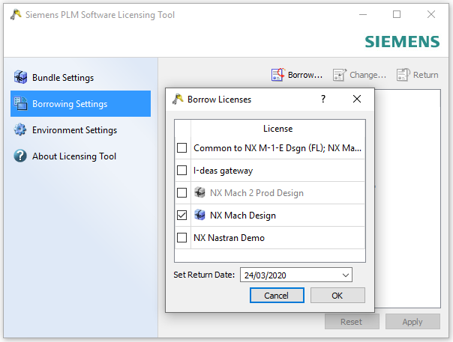
For further information on the license borrowing process please refer to the Solution Center article entitled ‘Options to Borrow an NX license’.
Note 1: License borrowing is enabled by default in NX license files issued since May 2017, and therefore no special arrangements are required to add the borrowing capability to a typical NX license file.
Note 2: NX license borrowing is typically user and NX version specific. This means that the borrowing procedure must be performed by the user that will run NX when offsite, and they must use the ‘Licensing Tool’ for the version of NX they intend to run. (A license borrowed for the latest version of NX cannot necessarily be used to run an earlier version of NX. If the requirement is to run two versions of NX then a license needs to be borrowed by and for each version.)
Note 3: There is a known issue when running NX with a borrowed license, where NX will freeze intermittently. This issue affects the use of NX 1847 Series and the initial release of NX 1872 Series. The issue is resolved in the NX 1872 Series - September 2019 update (NX 1884). Earlier or later versions of NX are not affected. If you are using one of these versions of NX, please contact your Account Manager and/or Technical Support to request temporary license to be deployed locally on the client workstation.

Accessing NX Data Managed in Teamcenter
With limited access to the office environment (and therefore Teamcenter), making the NX data available for offline working can be achieved using the NX – Teamcenter Export and Import utilities. The data will be stored and modified locally and then imported back into Teamcenter. An alternative approach is to use the Teamcenter Briefcase Browser functionality. This provides more advanced tools for the exchange of Teamcenter data (not just NX part files) in to and out of a Teamcenter database. Both approaches require due consideration, user training and testing to verify that they meet the data access requirements while ensuring that data integrity is maintained.

No Network Access to the Office Environment
If the remote user has no VPN access to the office environment, then alternative arrangements for licensing and access to data will be required, as outlined below.

NX License Borrowing
In order to borrow an NX license for offline working the NX client must be connected to the license server, so if there is no remote access to the license server the license borrowing must be perform before the NX Client is taken offsite. Details of the license borrowing process are outlined in Section 4.2.1 above.

Alternative NX Licensing Options
If license borrowing does not meet your requirements, then alternative licensing options need to be considered, as outlined below.

Local Licencing
Contact your Account Manager to request a time-limited server or standalone node-locked license to be deployed locally on the offsite workstation.
A server license will require that the Siemens PLM License Server software is downloaded and installed on the workstation. The Composite ID of the workstation is required to create a license file. This is obtained using the ‘getcid.exe’. (This utility is available in the ‘UGFLEXLM’ folder in the NX installation, as part of the NX media download, within an existing Siemens License server installation, or it can be downloaded from the support website.)
A standalone node-locked license may be easier to deploy, as it does not require a license server installation. The license file is simply placed on the workstation and the SPLM_LICENSE_SERVER environment variable is set the full path and name of the file. A standalone node-locked license is keyed to the MAC address of the workstation, which can also be obtained by running the ‘getcid.exe’.
Note: If the ‘Licensing Tool’ has been used on the NX client to define the ‘port@hostname’ value for the license server, this creates a Windows registry entry (NX_SERVER) that supersedes the SPLM_LICENSE_SERVER variable. The ‘Licensing Tool – Environment Settings – Edit’ option can be used to update this value. (Selecting the ‘Default’ button will remove the registry entry and revert to the SPLM_LICENSE_SERVER variable value.)
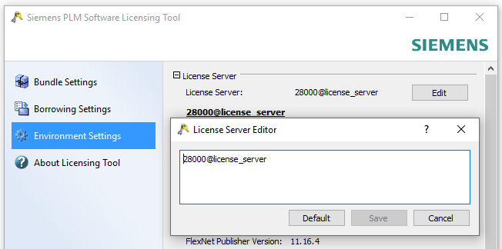
Note: If the license bundle selection has been made using the ‘Licensing Tool – Bundle Settings’ this creates a Windows registry entry (NX_BUNDLES) that supersedes the UGS_LICENSE_BUNDLE variable.

Emergency Licenses
If a license file is required urgently then an emergency license file can be download from the GTAC support site. An emergency license can be deployed on any computer with a Siemens PLM License Server installation, it is not locked to a specific host. The license is valid for 7 days, but a customer is limited to a maximum of 3 licenses in any 60-day period.

Cloud Licensing
If several NX users require access to a license, then consider deploying a license server in the cloud. The use of a virtual license server running on Amazon Web Services (AWS) or Microsoft Azure are supported. Please contact the cloud service provided for further details and the costs associated with the option. The host-id of the cloud server is required to create a license file, this is obtained by running the ‘getcid.exe’ in a command window with the ‘-cloud’ option, i.e. getcid -cloud
Changes to the firewall configuration on the cloud-based server and/or the NX client workstation may be required to enable communication to/from the license server. Consider fixing the network port number for the license server vendor daemon by specify a port number on the vendor line in the license file, for example:
VENDOR ugslmd PORT=28001
(The license server service will need to be restarted after adding the vendor daemon port number, a reread of the license file is not enough.)
Then ensure that the ports (28000 and 28001) are open for communication for the ‘ugraf.exe’ on the client side, and ‘lmgrd.exe’ (28000) plus ‘ugslmd.exe’ (28001) on the server side.

NX Data
If the remote user has no VPN access to the office environment, it follows that the NX data must be located and managed locally. For those users that typically work with data managed by Teamcenter, please refer to the data export and import options outlined in Section 4.2.2.

Summary
This document outlines the configuration requirements to enable a user to run NX from home and the options available to access a license and the NX data, in several different scenarios.
It is advisable that a customer reviews, implements and tests the selected configuration.
Although it is not the remit of the Siemens Technical Support team (GTAC) to provide or recommend solutions for a user to work from home, we are prepared to answer any questions that may arise on this subject.

Barry Wickson

